8 June 2007 The Weekly Bulletin of Rotary Club of Kathmandu Mid-Town Bc # 49 of 2006-07
Rotary Club of Kathmandu Mid-Town
Breakfast Chatter




District : 3290 Web: www.rotarymidtown.org.np Club Id : 26776

JUNE IS THE FELLOWSHIP MONTH
Rotary Fellowships . . .
. . . The Friend Makers !
Rotary Fellowships should not be the best kept secret in Rotary, but they are! There are over 70 different Rotary Fellowships. Each Rotary Fellowship focuses on a specific vocational or recreational discipline. Rotary Fellowships give Rotarians the opportunity to network with other Rotarians with whom they share interests. Fellowship is the foundation on which Rotary was built, and it is the source of Rotary's strength. Learn more about Rotary Fellowships and how they benefit you, your club and Rotary's global mission.

District Award Ceremony on Saturday, 26 May 2007.
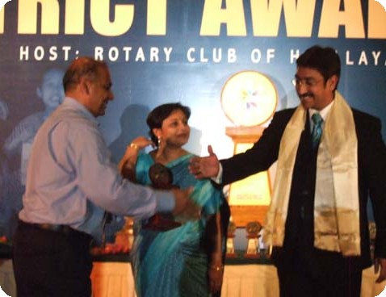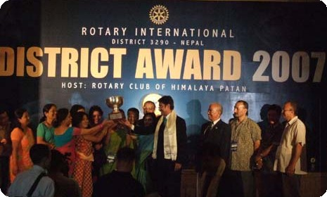
(a) District Governor Debasish Mitra congratulating President CK Golchha before handing him over 'Outstanding President' Award; First Lady Papia Mitra looks on.
(b) DG Debasish Mitra handing over the Best Club Award 2007 to Rotary Club of Yala;

Weekly Meetings and Programs :
Date | Program/Speaker | Program/Topics of Presentation
8 June 2007 | Dinner meeting | Induction and recognition
15 June 2007 | Joint meeting | Joint meeting with RC Rajdhani
22 June 2007 | Club Assembly

Friday, 8 June :
Dinner meeting ~ Venue : Hotel Grand, near Hotel Soaltee
~ Time : 18:30 hrs
~ Registration : Rs 600 per person, Rs 300 per child

District Awards 2007 :
a) Club Service
Membership Growth: First - Rotary Club of Rudramati; Second – Rotary Club of Mahabouddha;
Third – Rotary Club of Kathmandu North
Memberhsip Retention: First - Rotary Club of Kathmandu West; Second - Rotary Club of Patan;
Third - Rotary Club of Kathmandu Midtown
Club Bulletin: First - Rotary Club of Chitwan; Second - Rotary Club of Yala;
Third - Rotary Club of Patan Durbar Square

Participation in District Activities: First - Rotary Club of Damauli; Second – Kathmandu Midtown;
Third - Rotary Club of Patan West
Club Extension: First - Rotary Club of Pokhara Mid Town;
Rotary Image: First - Rotary Club of Yala; Second - Rotary Club of Narayangarh;
Third – Rotary Club of Kathmandu Midtown; Third - Rotary Club of New Road City Kathmandu
Inter Club Relation: First - Rotary Club of Yala; Second - Rotary Club of Dillibazar;
Third - Rotary Club of Kathmandu North East
Family of Rotary: First - Rotary Club of Yala; Second - Rotary Club of Narayangarh;
Third – Rotary Club of Kathmandu West
b) Vocational Service
Vocational Training: First - Rotary Club of Yala; Second - Rotary Club of Dillibazar;
Third - Rotary Club of Kasthamandap
Vocational Awards: First - Rotary Club of Yala; Second - Rotary Club of Bharatpur
Third - Rotary Club of Kathmandu
Career Counselling: First - Rotary Club of Diullibazar; Second - Rotary Club of Yala;
Third – Rotary Club of Itahari; Third - Rotary Club of Kathmandu Midtown;
Third – Rotary Club of Kathmandu North East; Third - Rotary Club of New Road City Kathmandu;
Third – Rotary Club of Patan
Cont'd ….

International Biofuel Forum :
The world's two top ethanol producers – the US and Brazil - announced the creation of an international forum to help expand the global market for biofuels. The forum will meet regularly for a year to draft global standards for biofuel production, find ways to open markets and encourage investment in countries with the potential to develop the industry. By working together we will be able to identify ways to help countries with agricultural potential become major energy suppliers. Brazil is the world's biggest ethanol exporter, using sugarcane to produce it. Eight out of 10 Brazilian cars run on ethanol, which emits far less greenhouse gases than fossil fuels. In the US, where farmers use corn to make ethanol, production surpasses that in Brazil. Corn farmers in the US don't like the idea of the government helping Brazil's industry. But the issue of moving the world off of fossil fuels was more important than any bickering over a Brazil-US agreement. Biofuel cannot be promoted by just one country. It is a global issue. Brazil's method of producing ethanol is better than the American way. Sugarcane-based ethanol is far cheaper to make than corn-based ethanol.
Source: The Kathmandu Post

On Lighter Side : Click at the figure ⇩


Every project I have seen has impressed me in its own way. The projects that have impressed me the most, however, have been those addressing a need that no one has been able to meet before, whether because of a lack of resources, a lack of ability, or simply a lack of awareness.
RI President William B. Boyd

8 June 2007 The Weekly Bulletin of Rotary Club of Kathmandu Mid-Town Bc # 49 of 2006-07

Editor: RR Shrestha, Club Service Director email: rryes@wlink.com.np

